**How successful were the Oslo Accords?**

**Lesson 12**

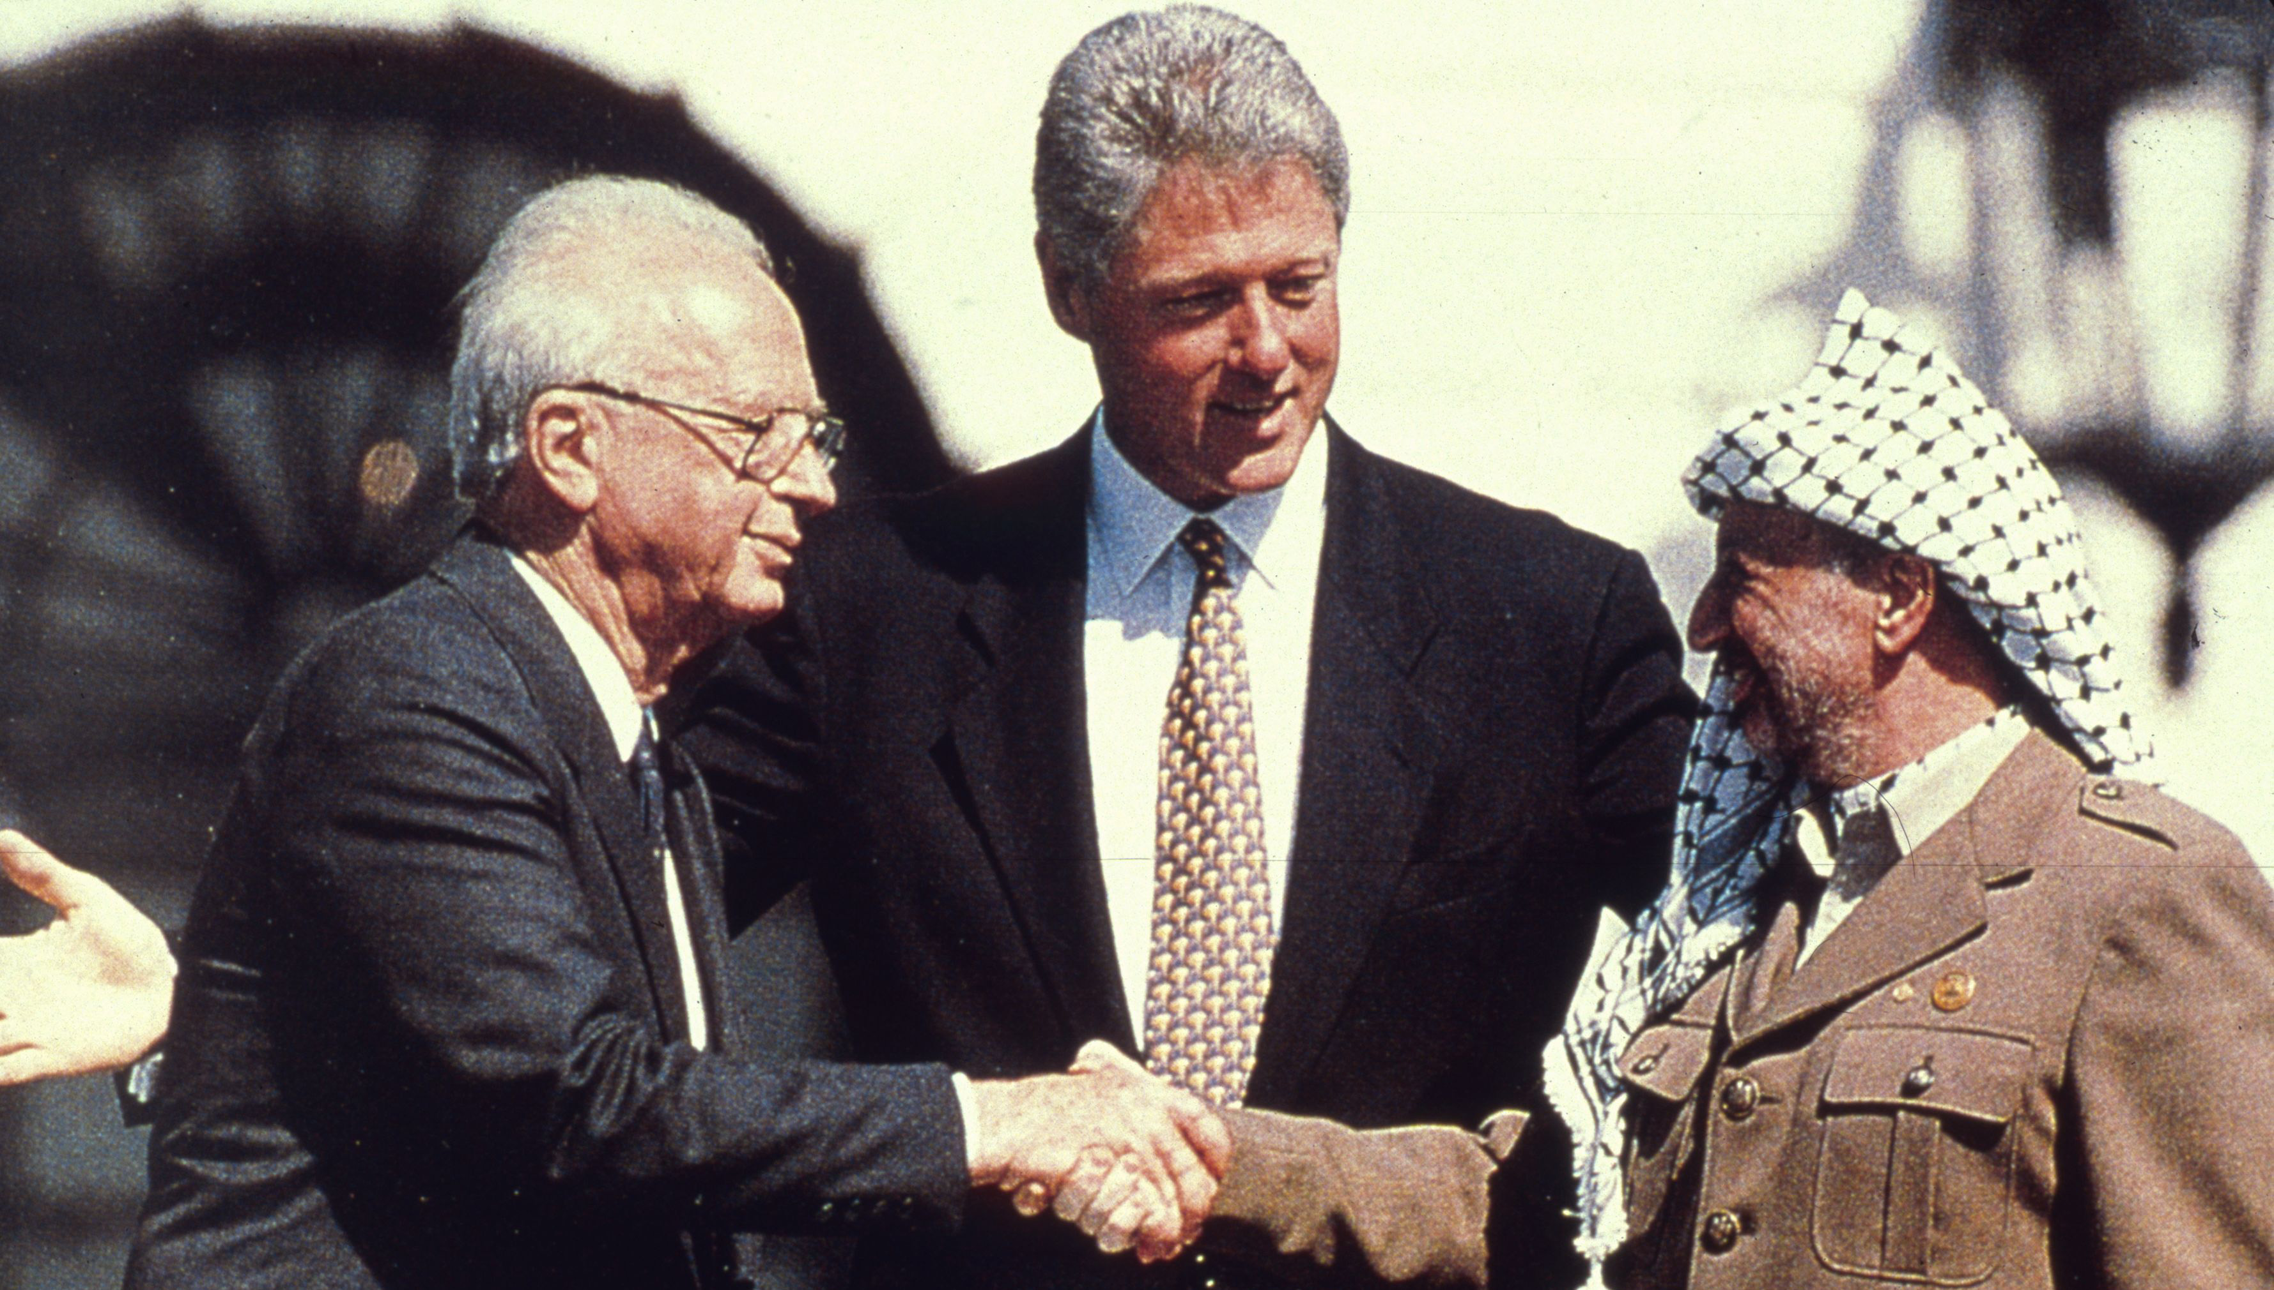

**By the end of this lesson, you should be able to:**

Describe what the Oslo Accords were

Explain why the Oslo Accords were celebrated

Discuss the success of the Oslo Accords

**Keywords**

Oslo Accords

Peace process

Johan Jorgen Holst

Yitzhak Rabin

**Knowledge check!**

1)What was the First Intifada?

2)What was life like for Palestinians between 1967 and 1987?

**The Oslo Accords**

*agreements between Israel and the PLO in 1993 and 1995. They agreed to work together for 5 years to reach an agreement about the future of Palestine and Israel*

**The details**

First, both sides **recognized the legitimacy of the other**. In 1988, the PLO recognized Israel as a country, and in 1993 Israel recognized the PLO as representative of the Palestinian people

On 13th Sep 1993 in Washington DC, Oslo I was signed: The Declaration of Principles on Interim Self-Government Arrangements

“The Government of the State of Israel and the PLO team (in the Jordanian Palestinian delegation to the Middle East Peace Conference) (the "Palestinian Delegation"), representing the Palestinian people, agree that it is time to put an end to decades of confrontation and conflict, recognize their mutual legitimate and political rights, and strive to live in peaceful coexistence and mutual dignity and security and achieve a just, lasting and comprehensive peace settlement and historic reconciliation through the agreed political process”

Israel and the PLO also agreed that:

- an elected Palestinian parliament would be established

- Israel would gradually withdraw from some parts of Gaza

- the PLO would distance itself from terrorist groups

Two years later, on 28th Sep 1995 in Taba, Egypt, Oslo II was signed. Israel and the PLO agreed that Gaza would be part of Palestine, and that the West Bank would be *temporarily* split into three areas: A, B and C

**1993 & 1995 Oslo Accords**

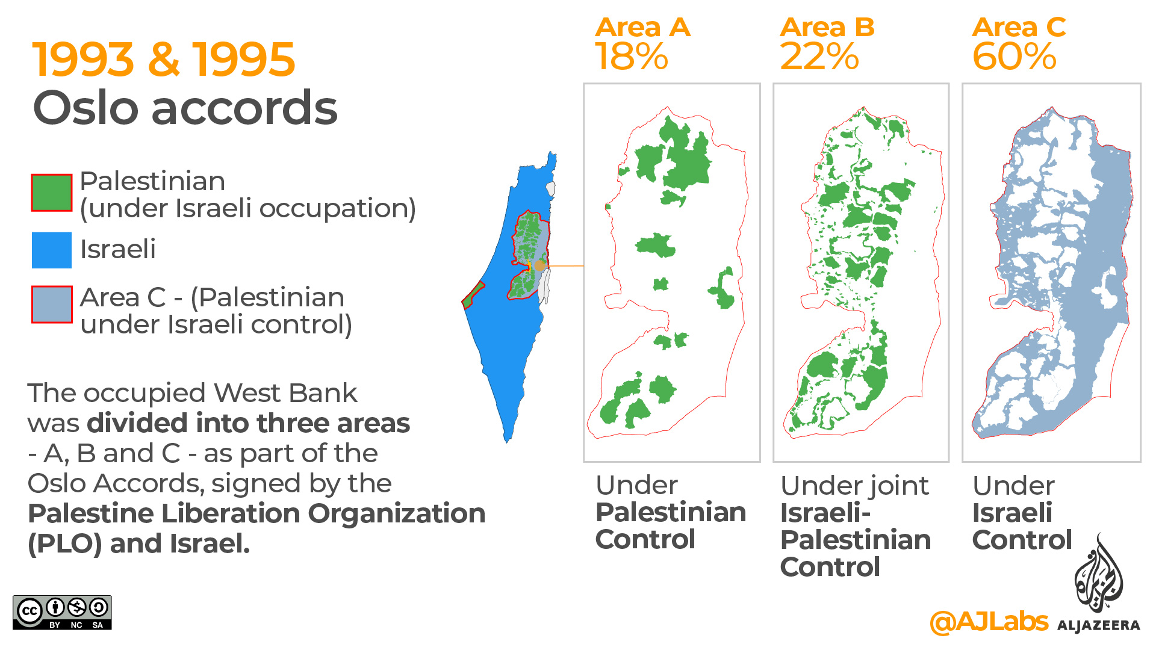

**Letters of ‘mutual recognition’**

Letter A

September 9, 1993

Mr. Prime Minister (Yitzhak Rabin),

The signing of the Declaration of Principles marks a new era... I would like to confirm the following PLO commitments: The PLO recognizes the right of the State of Israel to exist in peace and security… The PLO commits itself...to a peaceful resolution of the conflict between the two sides… the PLO renounces the use of terrorism and other acts of violence…

Sincerely,

Yasser Arafat (Chairman of The Palestine Liberation Organization)

Letter B

September 9, 1993

Mr. Chairman (Yasser Arafat),

In response to your letter of September 9, 1993, I wish to confirm to you that, in light of the PLO commitments included in your letter, the Government of Israel has decided to recognize the PLO as the representative of the Palestinian people and commence negotiations with the PLO within the Middle East peace process…

Yitzhak Rabin (Prime Minister of Israel)

**Activity**

Read through the letters and identify the most significant parts. Why are these parts significant?

**Questions**

1)Why were the letters of ‘mutual recognition’ important?

2)What is a ‘peace process’?

3)Why were the Oslo Accords seen as the start of a peace process?

**Why the Oslo Accords?**

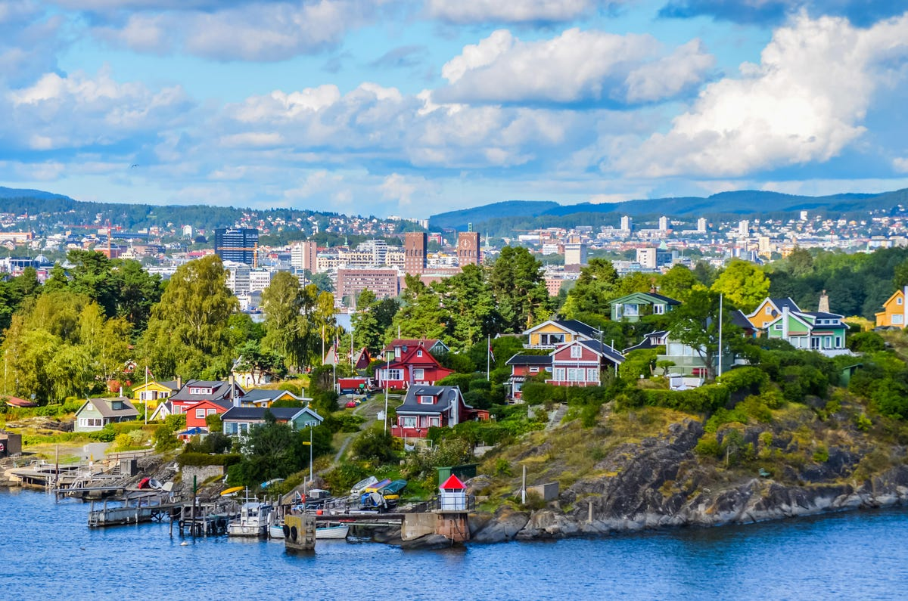

Because Oslo in Norway is where the secret negotiations that led to the Oslo Accords began. The negotiations were started by Johan Jorgen Holst, the Norwegian Foreign Minister

**The start of a ‘peace process’**

This was the first time that Israel had recognised the PLO as representative of the Palestinian people, and it was only recently that the PLO had recognised Israel’s right to exist. This was an important first step. Both Israel and the PLO now appeared committed to achieving peace. However, this did not go to plan

**What happened?**

At first, things went according to plan. Israel withdrew troops from Gaza and Jericho, and under the 1994 Gaza-Jericho Agreement, an elected Palestinian parliament was established: the Palestinian Authority (PA)

However at the same time, Israeli settlements continued to be constructed in the West Bank and Israel felt that the PA was not distancing itself adequately from terrorist groups

**Discussion**

1)How would you feel about these developments if you were:

a. Palestinian?

b. Israeli?

**So was a peace agreement reached?**

Unsurprisingly, neither side felt that the other was keeping its end of the deal. So the goodwill that was so crucial to reach an agreement between Israel and Palestine **deteriorated** **and no peace agreement was reached**

And then the Camp David Summit failed in 2000, paving the way for the *Second Intifada*

**Areas A, B and C**What happened to the Palestinian land that had *temporarily* been divided into areas A, B and C under the Oslo Accords? This "temporary” division of Palestinian territory remains in place today

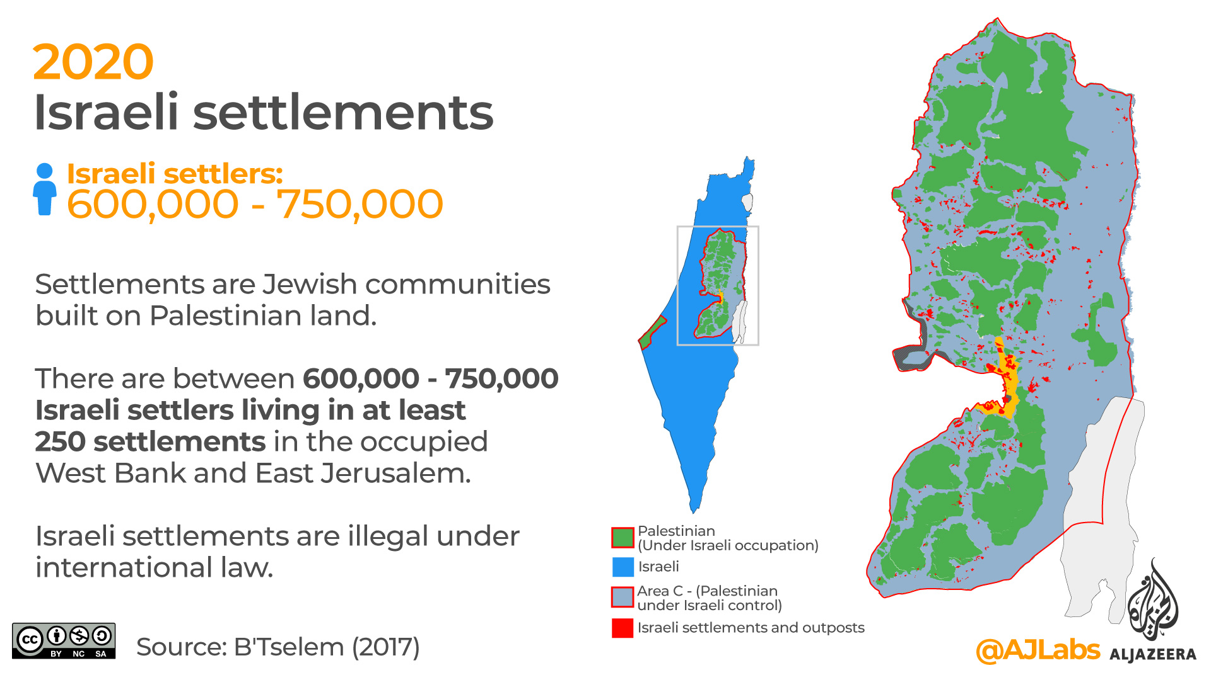

**Activity**

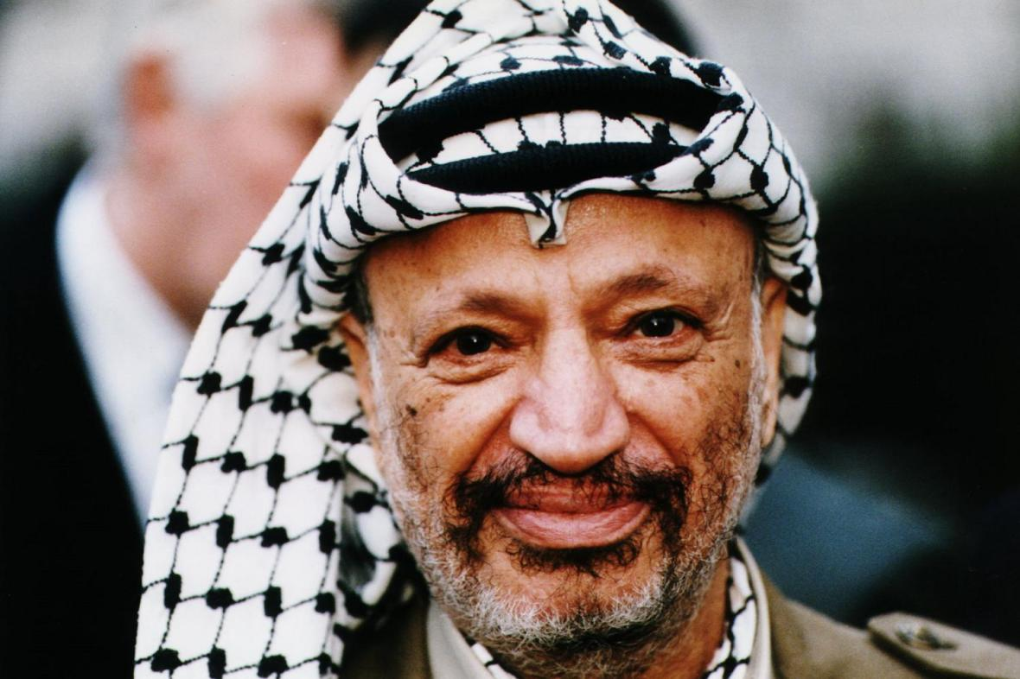

Answer the questions below using these keywords:

-Oslo Accords

-Peace Process

-Johan Jorgen Holst

-Yitzhak Rabin

1)What were the Oslo Accords?

2)Who signed the Oslo Accords? When? Where?

3)Why were the Oslo Accords significant?

4)How successful were the Oslo Accords?

**Extension activity**

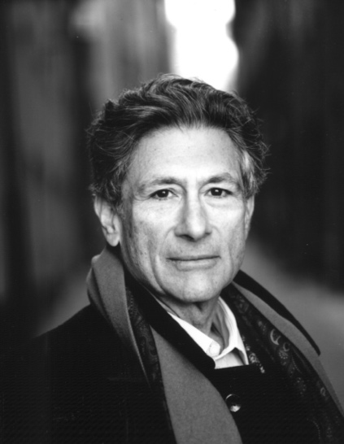

Edward Said on the Oslo Accords: “let us call the agreement by its real name: an instrument of Palestinian surrender, a Palestinian Versailles”

The Oslo Accords have been described by Palestinian public intellectual Edward Said as a **“**Palestinian Versailles”

To what extent were the Oslo Accords a Palestinian Versailles? Remember to justify and contextualise your answer

Hint:

WWI ended on 11th November 1918, when Germany surrendered and all nations had agreed to stop fighting. On 28th June 1919, the Treaty of Versailles formally ended the war. This was negotiated at the Paris Peace Conference and it was signed by Germany, Britain, France, Italy and Russia. The Treaty of Versailles had huge consequences for Germany. Germany had to accept full responsibility for the war under the ‘War Guilt Clause’ (Clause 231), it lost a great deal of territory and 10% of its population. Germany also had to pay 132 billion gold marks in reparations, which is the equivalent of $269 billion today. There were also severe military restrictions on the country